TITLE OF PAPER (font formats - CAMBRIA, 13 pt bold, ALL CAPS; paragraph formats: centered, spacing before 0 pt, spacing after 11 pt)

Authors (Surname Name) (Font formats - Cambria, 11pt bold, centered, spacing before 0 pt, spacing after 0 pt)
Affiliation (Style Affiliation: 10pt, centered, spacing before 0 pt, after 10 pt)
Abstract (italic, bold): Short abstract up to 250 words (Style Abstract: 10 pt, italic, justified).
Key words (italic, bold): key word 1, key word 2... to (max) key word 5

Main Heading (font formats - CAMBRIA, all caps 11 pt, LEFT, spacing before 12 pt, spacing after 6 pt)
Main text: only use characters and symbols available in the Cambria or Symbol font (as in the full text of paper), 11 pt; paragraph format: justified alignment, left and right indent 0 pt, space before and after 0 pt, first line indent 0.6 cm.

Subheading (Font formats – Cambria, 11 pt, bold, left, indentation left 0.6 cm, spacing before 12 pt, after 6 pt)
Sample of main text. Sample of main text. Sample of main text. Sample of main text. Sample of main text. Sample of main text. Sample of main text. Sample of main text. Sample of main text. Sample of main text. Sample of main text. Sample of main text. Sample of main text. Sample of main text. Sample of main text. Sample of main text. Sample of main text. Sample of main text Sample of main text. Sample of main text. Sample of main text. Sample of main text.

Subheading (Font formats – Cambria, 11pt, italic, left, indentation left 0.6 cm, spacing before 12 pt, after 6pt)
Sample of main text. Sample of main text. Sample of main text. Sample of main text. Sample of main text. Sample of main text. Sample of main text. Sample of main text. Sample of main text. Sample of main text. Sample of main text. Sample of main text.

Tables

Table title (Font formats – Cambria, 11pt, centered, spacing before 12 pt, after 6 pt).
Table (Font formats – Cambria, 10pt, centered, spacing before 0 pt, after 0 pt).
Table 1 Title of table (Style Table title)
 | Wilks | F | Effect df | Error df | p
AGE | 0.334 | 5.11 | 20 | 140 | 0.000*
SEX | 0.589 | 4.88 | 10 | 70 | 0.000*
SEX*AGE | 0.743 | 1.12 | 20 | 140 | 0.336
Legend: F – value of the Wilks test for analyzing the significance of difference between centroid of groups; Effect df, Error df – degrees of freedom; p – significance coefficient.
All tables should be numbered with consecutive Arabic numbers. They should have descriptive captions at the top of each table and should be mentioned in the text. Tables should accompany the manuscript, and should not duplicate any results presented elsewhere in the manuscript (e.g. in graphs). All the necessary explanations and a legend of the abbreviations have to be provided at the bottom of each table (Font formats – Cambria, 9pt, centered, spacing before 6 pt, after 6pt).

Illustrations: figures, photographs, line drawings, graphs
(Styles Figure and Figure Title)
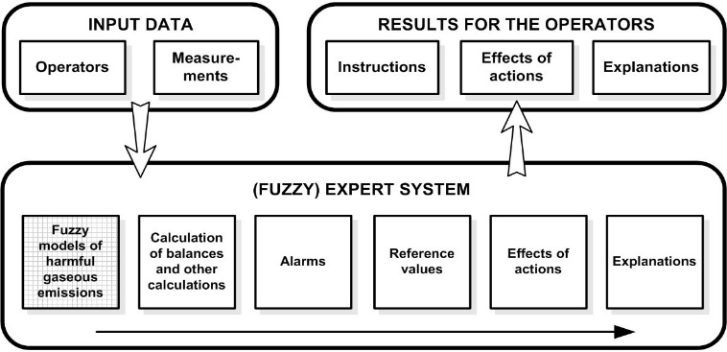
Fig. 1 Title of figure
All illustrations (figures, photographs, line drawings, graphs) should be numbered in series and all legends should be included at the bottom of each illustration. All figures, photographs, line drawings and graphs, prepared in electronic form, should be converted in TIFF or JPG (max quality) files, in 300 dpi resolution, for superior reproduction. Figures, line drawings and graphs prepared using elements of MS Drawing or MS Graph must be converted in form of pictures and unchangeable. All illustrations should be planned in advance so as to allow reduction to 16.00 cm in column width. Please review all illustrations to ensure that they are readable.

Equations should be prepared using Equation Editor as a part of MS Word, with styles and sizes as defined (see Fig. 2).
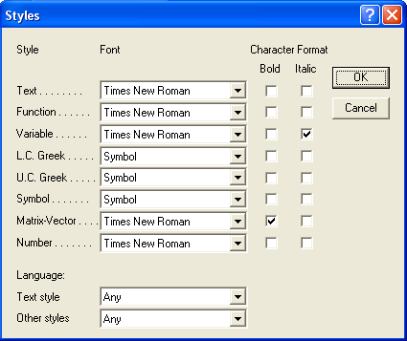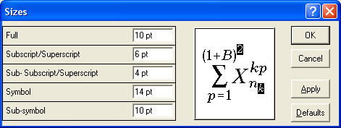
Fig. 2 Title of figure
(2)
Paragraph format for equations are (Style Equation): left indentation, 6 pt before and after, equation is at position of centered tab at 8 cm, number of equation is at position of right tab at 16 cm.
Acknowledgement: The paper is a part of the research done within the project 1234567890. The authors would like to thank to the... (Style Acknowledgement).

References (Font formats – Cambria, 10pt, left, hanging 0,6 cm, spacing before 0 pt, after 0pt)
(Samples for Journal, Book, Section from book, Unpublished Paper, Proceeding, Thesis, Internet Document- Style Reference)
- Kohrt, W.M., Obert, K. A., & Holloszy, J.O. (1992). Exercise Training Improves Fat Distribution Patterns in 60-to 70-year-old Men and Women. Journal of Gerontology, 47 (4), 99-105.
- Hofman, J. (2006). Norms for Fitness, Performance and Health. Champaign: Human Kinetics.
- Mason B.R., & Formosa D.P. (2011). Competition analysis. In S. Ludovic, C. Didier, & M. Inigo, World book of swimming: From science to performance (pp.411-424). New York: Nova Science Publishers, Inc.
- Radovanović, D., Aleksandrović, M., & Georgiev, G. (2005). Defining canonical correlations of functional and situation-swimming motor skills of 12 years old water polo players. In: Milanović, D. & Prot, F. (Eds.), 4th International Scientific Conference on Kinesiology ”Science and Profession – Challenge for the Future”. (pp. 713-715), Zagreb: Faculty of Kinesiology.
- Vest, A.L. (1995). Model nekaterih energijskih značilnosti kajakašev (Model of some energy-characteristics of water-slalom kayakers). Unpublished doctoral dissertation, Ljubljana: Fakulteta za sport.
- Fredrickson, B.L. (2000, March 7). Cultivating positive emotions to optimize health and well-being. Prevention & Treatment, 3, Article 0001a. Retrieved November 20, 2000 from http://journals.apa.org/prevention/ pre0030001a.html
- Electronic reference formats recommended by the American Psychological Association. (1999, November 19). Washington, DC: American Psychological Association. Retrieved May 3, 2000, from the World Wide Web: http://www.onlinebachelordegreeprograms.com/apa-style-guide-for-psychologists/

STRUCTURE OF THE MANUSCRIPT (length up to 8 pages)
A research article should report original research, presenting all the standard elements of a scientific investigation: the INTRODUCTION, METHOD (including participants, instruments and procedure), RESULTS, DISCUSSION, CONCLUSION, ACKNOWLEDGMENTS, REFERENCES and LEGENDS (Illustrations, Tables and Equations).
A review article is a critical evaluation of material that has already been published. A review article should include an analysis, evaluation, and synthesis and should not just be a reproduction of scientific facts. It is composed of the following sections: problem definition, summary of previous research, explanation of subject matter inter-relations, contradictions, problems and suggestions for further research. It includes the following sections: the INTRODUCTION, MAIN TEXT, CONCLUSION, ACKNOWLEDGMENTS, REFERENCES and LEGENDS (Illustrations, Tables and Equations).
A preliminary research report should present the findings of a research report, outlining all the standard elements of scientific investigation. It represents a short report on the completed part of an original research project which is still in progress. Reports of professional practices will need to demonstrate academic rigor, preferably through an analysis of program effectiveness, and should go beyond mere description. A preliminary research report includes the following sections: the INTRODUCTION, METHOD, RESULTS, DISCUSSION, CONCLUSION, ACKNOWLEDGMENTS, REFERENCES and LEGENDS (Illustrations, Tables and Equations).,

